Yash Bagri

Final Submission Documentation

**Introduction:**

The game that I did an audio overhaul for was [Overjammed](https://github.com/Nachodlv/overjammed) a unity WebGL game made for a game jam called Ludum Dare. The game is about managing the stress of 4 game developers in a game jam as they try to complete the game, as is progresses they have problems that pop up that the player must address otherwise their stress level will go too high and they will quit. If you last through the whole time period, you win the game.

**Analysis of Game:**

The game has a small but constant noise pool to dive into and change up to change the atmosphere of the game and enhance it. The game uses a persistent soundtrack on the menu and game screen, and a series of one-shot sounds that is used for the game’s problems from developers and interactable items. The sound design was simple in the game so I thought I could easily introduce more complicated sound design using the FMOD system to add depth to the game stage. For the one-shots, I felt the game was in an in between cartoonish noise design and realism with accurate water pouring noises but a cartoony pop for getting an apple from the fridge. I felt that I could make these sounds more consistent in realism while keeping the light tone of the game. The emotion one shots the game uses are cartoony and a little hard to distinguish certain emotions, so my goal with that was to make the emotion sounds more distinct while keeping a lighter cartoony feel of the original game. I thought to add ambience and game music that changes with the developer’s stress level. As you get closer to losing, the sounds get more intense and become calmer when stress levels are low.

**Sound Asset Development:**

For the grab item sound, I used a op noise from free sound. In the sound I used a high pass to get rid of garbage noise at 60hz and below. After that I boosted the 200Hz to 500Hz frequency wave by around 6.6db and high shelfed 4600Hz up by around 7dbs, and lastly lowered around 2200Hz by around -3db. This was to give the pop more bass and resonance to it to make it more ear catching and interesting compared to the original in game pop sound used. After this I compressed the audio to make it more even for the game. This was to be used to pick up the ball that drops as that did not have a noise and I felt that this could be placed onto that.

For the correct chime I took the sample and focused on dampening the noise to be less harsh by lowering the mid and low frequencies by -4db along with a high pass at 125hz. I high shelfed 11000Hz by 4db to bring some ring back to the noise after the cuts and get it some energy again. After this I compressed the audio to make it more even, after that I used TAL Reverb at a low mix level to add just a smidge of depth to the sound. This was to make a fun noise to motivate the player after clicking on the buttons.

For the fish food bubbles noise I followed a similar process as the grab item, boosting lows and highs while cutting mids. I high shelfed around 5000Hz to bring a long more ring to the bubbles and hear the popping of them more distinctly. Compressed to make it even, then added slight reverb to give it a smidge more depth to the noise like the correct ding. This was to emulate a fish chomping the food after you put it in the tank.

For the coffee pouring, I lowered the low frequencies and high passed the noise, this removed some boominess from the sound and made more space or the pouring noise. I raised both the mids and the highs by about 3db in order to focus in on the pouring sound from the sample and have it come up higher than it was originally. Compressed to make the sound more even. This was to make a realistic pour noise for the coffee in the game’s office.

For the fridge opening I ran a reafir on the original sample to remove the room noise from it as there was a lot. From there I separated the opening and closing noises. I raised the lows on the opening to make it more boomy and have strength to the noise. For the close I uniformly took down all the frequencies a couple db to make it less harsh and fall in line with the opening noise. Both were compressed to be more even. This was to make getting the apple a more realistic noise.

For the router break noise, I used a Vital preset (Random Amp Growl by Afro) to make a bass like growl sound when played at a higher tone sounds like a error noise from some kind of electrical appliance. I removed around -3 to -6db from the mids and highs from this to remove some of the ring and focus more on the growl on the song. I used a midi to play a note three times to emulate an error sound to come from something when its not working.

For watering the plant, I used a spray bottle sample to fit a more hectic workspace compared to the original which used a pouring noise for this. I raised the highs and mids in an eq by around 2-3db for get more ringing from the high end and make the spray sound more distinct. Compression used to make it sound more even.

For the walking sound, I just used a sample and cut up three different sounding effects. I compressed them to make the sound more even and hear it more distinctly. The sound was already close enough to what I envisioned walking on carpet with office shoes sounds like, so no other editing went into this sound.

The AC noise is used to add ambience to the game room to help create the feeling of a working space. For this noise I added both a high pass and a low pass to it at 4400Hz and 130Hz respectively as both those ranges added a high-pitched whirr sound in the high end and a boom of the AC parts moving in the low end. By running the passes on them these sounds get reduced immensely, then by boosting the low mids and mid frequencies I was able to solo in on the air flowing noise from the ac and make it sound pleasant. Added slight reverb to add depth.

White noise was used to add depth to the ambience noises and fill out the noise spectrum a bit. The whole sample was dampened removing dbs at all frequencies to make it less noticeable and able to blend into the rest of the ambience easier.

For all the emotion noises, I used a mixture of a sample and recording my own voice to make the noises. These were used to try to emulate more realistic noises made for these emotions. All were passed in an EQ in order to make the sound richer (high pass super lows, boost mids, lower low mids etc). Except for the bored sigh noise which was dampened all around as the original sample was very harsh.

For the game ambience, I used a crowd noise sample and keyboard typing in an office sample. Both were compressed to make more even and were dampened across the spectrum to make them less distinct and able to fall into the background easier. These were used to emulate the devs typing on their keyboard and discontent for when they are stressed.

For the menu music, I made a tune using Vital synth and a square wave to make a chiptune like/8-bit sounding track that fit the aesthetics of the game. It was a pluck like envelope to make it sound snappy and cheery when played in small notes.

For the game over music, another square wave played with a 2-note chord going down to make a sad noise and get across to the player that they failed their task.

For the game music, I used a square wave pluck synth to make a cheery melody playing quick single notes. I added a piano with the DSK Grand to play sadder more unnerving chords. And lastly a sine wave played with the vital synth at a low tone. These last two are used to create unease in the player since they will come on when the stress level is high. First the piano will kick in then the low bass from the sine wave which will add edge and worry to the player to make then try to address the devs quicker.

**FMOD Work:**

For FMOD the game is organized into 5 folders, Ambience, BGM, Emotions, Problems, and SFX. In Game_Ambience, it used two single instruments, one for keyboard typing and one for crowd noise, and plays both on a loop. They are tied to a global variable “excitement” which will lower the keyboard noises and raise the crowd noise as the parameter gets higher. ASDR envelope added to it to let it fade out with the other game sounds after the game screen ends. Walking is just a multi-instrument of 3 step sounds to be played as oneshots in the game on a set time interval. There is a 3-semitone randomness added to make them sound more natural and different. White_Noise is just a loop of the white noise sample.

For the BGM folder, Game_Over is a one-shot of the game over tune I made, it’s start is offset 200ms to account for the game audio needing to fade out on game loss. The Menu song is just a loop of the menu song tune I made. ASDR envelope added to it to let it fade out with the other game sounds after the game screen ends. The Game_Song event has the square pluck, piano chords, and the bass sine wave on 3 different single-instrument tracks being looped. The excitement global parameter will raise the piano and sine wave from being unheard to being hearable and 2 specific excitement levels to signify the player is in danger. ASDR envelope added to it to let it fade out with the other game sounds after the game screen ends.

All the Emotion events are Multi-track instruments with each of their respective emotions loaded into them. They are randomized by 3 semitones every play to create variation and are played as one-shots.

All the problem events aside from AC event, are single instruments for their one shot with 3 semitone randomizations to create variation. The apple event has the open and close sample separated to be in time with the game’s fridge animation for opening and closing. The AC noise is a persistent noise that is always played in game. ASDR envelope added to it to let it fade out with the other game sounds after the game screen ends.

For the SFX folder, Grab_Item is a single-instrument item for a one shot, randomized 3 semitones for variance. The Correct event is a single-instrument track and is pitched up 12 semitones to add energy to the sound and make it cheerier which falls in line with the game’s feel.

**Mixing:**

For mixing I had to focus a lot on levelling out the noise. For the crowd noise I had to raise it to around 8db higher than the original sample at highest excitement since it was barely hearable in the game until right before game over. For the game_song event I have the piano and the sine wave come in very drastically at 2 excitement points to get the player by surprise and introduce anxiety into the player to let them know they are close to losing. I had to lower the Menu -3db and raise the game_over 6db to make them more manageable in their hear ability. All emotion events were boosted 1.5-3.5db to make them more distinct when playing the game. I raised Pour_Coffee and Feed_Fish 2db and 4db respectively to make in more even with the other problem events. I added a sidechain to the Interactables bus which held both problems and emotion events (aside from AC) which were then used by compressors on both the Ambience bus and the BGM bus to duck them out when an interactable played. This made them more ear catching and legible to hear in game. The compressor was only set to compress 1.3db as higher than that made it super noticeable and could barely hear the bgm. I lowered the SFX bus -4db to make it more even with the rest of the game.

**Mastering:**

For mastering I set my target to -14 Lufs. I used 3 games as reference, Battle Block Theatre, Sonic Mania, and Shantae and the Pirate’s Curse. These games were all pretty loud, Shantae was -14 lufs, Sonic mania was -13 Lufs and Battleblock went all the way up to -11 Lufs. I decided to aim between Shantae and Sonic Manie so I went with -14 Lufs target. My game already had a natural -16 lufs just from my mixing. I boosted the master track by 2.5db and put a limiter on it to -1db to keep a ceiling on it. From hear I went over into 12 lufs specifically from my correct noise (especially when spammed) so I had to lower that noise down to make it more even and only boost the Lufs a little bit when pressed. Mastering screenshot:

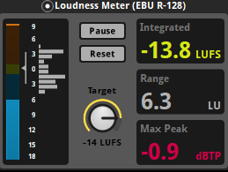

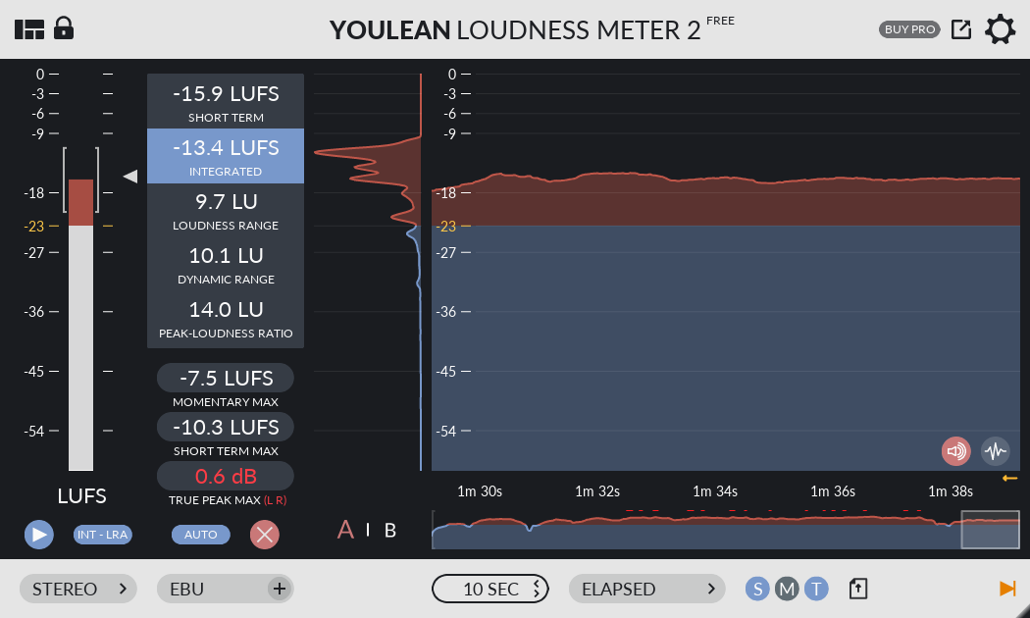

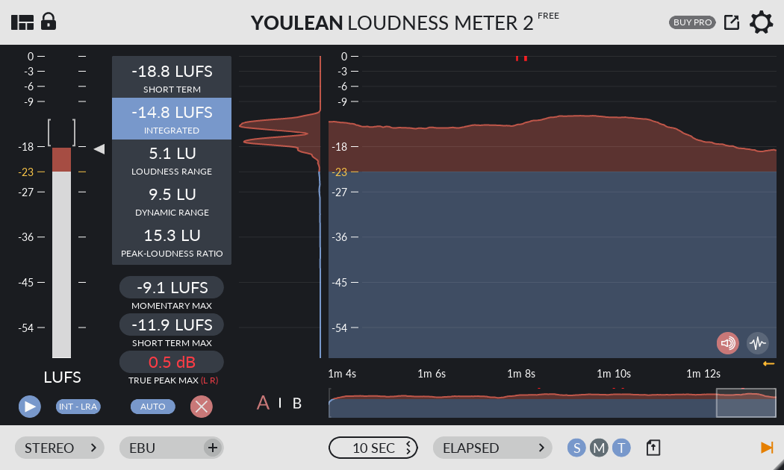

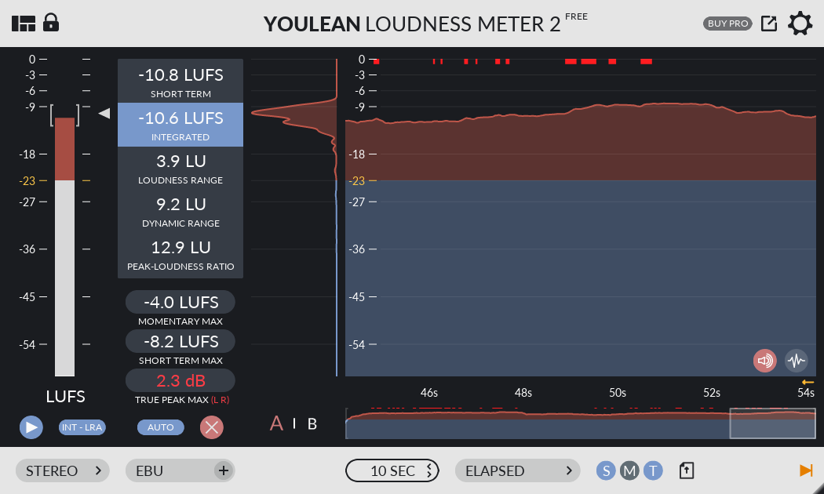

**Audio Sources:**

walking cartoon 3.WAV cupido-1

https://freesound.org/people/cupido-1/sounds/456392/

pouring coffee.wav Rico_Casazza

https://freesound.org/people/Rico_Casazza/sounds/538932/

Electrical Noise constructabeat

https://freesound.org/people/constructabeat/sounds/258362/

Night Recordings » Air Conditioner.wav JonathanTremblay

https://freesound.org/people/JonathanTremblay/sounds/254779/

feedback-correct » correct3.wav StavSounds

https://freesound.org/people/StavSounds/sounds/546081/

Office Sounds » white noise.wav florianreichelt

https://freesound.org/people/florianreichelt/sounds/448213/

Recorder Comparisons » Pop, High, A (H1).wav InspectorJ

https://freesound.org/people/InspectorJ/sounds/411642/

Bubbles » Bubbles 003.wav ristooooo1

https://freesound.org/people/ristooooo1/sounds/539820/

plants-watering Eelke

https://freesound.org/people/Eelke/sounds/144422/

household sounds » refrigerator door opening and closing.wav sethlind

https://freesound.org/people/sethlind/sounds/265024/

Sigh2.wav K1m218

https://freesound.org/people/K1m218/sounds/60669/

Sigh1.wav

https://freesound.org/people/K1m218/sounds/60668/

cry.wav silversatyr

https://freesound.org/people/silversatyr/sounds/113364/

sad.wav the_sider95

https://freesound.org/people/the_sider95/sounds/394624/

Final Audio1 » anger ssierra1202

https://freesound.org/people/ssierra1202/sounds/391939/

Party Crowd Daniel Simion

https://soundbible.com/2163-Party-Crowd.html

Typing On Computer Keyboard (No Auther name)

https://soundbible.com/358-Typing-On-Computer-Keyboard.html

Man Coughing Mike Koenig

https://soundbible.com/501-Man-Coughing.html